Geometry Proof Presentation Format

Definition
# Source: AI Source: Provided by: [Data Path: Persons Table -> ID Column: 1, Name_En Column: Motasem Essam] -> From: [ChatGPT] on [7/25/2026]
Geometry Proof Presentation Formats are different ways of organizing and displaying the logical steps of a geometric proof so that the reasoning from the given information to the conclusion is clear and easy to verify.
A presentation format determines how the proof is written, not the underlying logical method or geometric framework.
$$\boxed{\text{Given}→\text{Statements + Reasons}→\text{Conclusion}}$$

Simple Definition
# Source: AI Source: Provided by: [Data Path: Persons Table -> ID Column: 1, Name_En Column: Motasem Essam] -> From: [ChatGPT] on [7/25/2026]
A geometry proof presentation format is the written or visual structure used to present a proof.
For example, the same proof can be presented as:
- a Two-Column Proof
- a Paragraph Proof
- a Flow Proof
The mathematical reasoning can remain the same even though the presentation changes.

Main Types
# Source: AI Source: Provided by: [Data Path: Persons Table -> ID Column: 1, Name_En Column: Motasem Essam] -> From: [ChatGPT] on [7/25/2026]
A practical classification is:
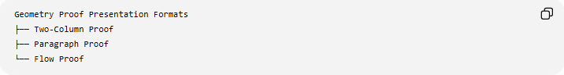
Geometry Proof Presentation Formats
├── Two-Column Proof
├── Paragraph Proof
└── Flow Proof
These are the three most common formats in elementary and secondary Euclidean geometry.
Important: This classification concerns presentation, not the logical method used to prove the statement.

1. Two-Column Proof

Definition
# Source: AI Source: Provided by: [Data Path: Persons Table -> ID Column: 1, Name_En Column: Motasem Essam] -> From: [ChatGPT] on [7/25/2026]
A Two-Column Proof presents a geometric proof in two corresponding columns:
Statements | Reasons
What is mathematically stated | Why the statement is true
The left column contains the mathematical steps, while the right column contains the justification for each step.

Basic Structure
# Source: AI Source: Provided by: [Data Path: Persons Table -> ID Column: 1, Name_En Column: Motasem Essam] -> From: [ChatGPT] on [7/25/2026]
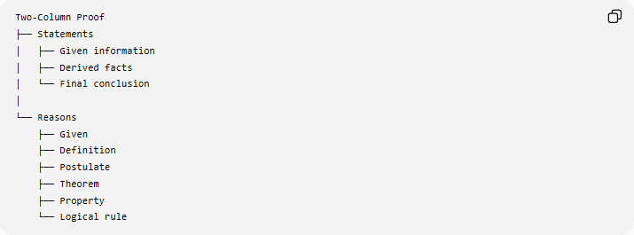
Two-Column Proof
├── Statements
│ ├── Given information
│ ├── Derived facts
│ └── Final conclusion
│
└── Reasons
├── Given
├── Definition
├── Postulate
├── Theorem
├── Property
└── Logical rule

Example
# Source: AI Source: Provided by: [Data Path: Persons Table -> ID Column: 1, Name_En Column: Motasem Essam] -> From: [ChatGPT] on [7/25/2026]
Given
In $△ABC$:
$$AB=AC$$
Prove
$$∠B=∠C$$
Two-Column Proof
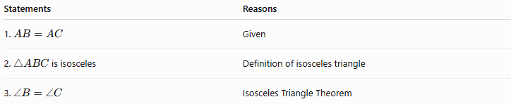
Statements | Reasons
1. $AB=AC$ | Given
2. $△ABC$is isosceles | Definition of isosceles triangle
3. $∠B=∠C$ | Isosceles Triangle Theorem
Therefore:
$$\boxed{∠B=∠C}$$

Another Example Using Congruence
# Source: AI Source: Provided by: [Data Path: Persons Table -> ID Column: 1, Name_En Column: Motasem Essam] -> From: [ChatGPT] on [7/25/2026]
Given
$$AB=AC$$
and $AD$bisects $∠A$.
Prove
$$BD=DC$$
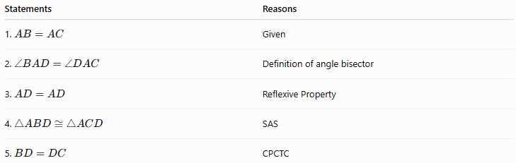
Statements | Reasons
1. $AB=AC$ | Given
2. $∠BAD=∠DAC$ | Definition of angle bisector
3. $AD=AD$ | Reflexive Property
4. $△ABD≅△ACD$ | SAS
5. $BD=DC$ | CPCTC

Advantages
# Source: AI Source: Provided by: [Data Path: Persons Table -> ID Column: 1, Name_En Column: Motasem Essam] -> From: [ChatGPT] on [7/25/2026]
- Very structured.
- Each statement has an explicit reason.
- Easy to check step by step.
- Useful for learning formal proof writing.
- Makes logical gaps easier to identify.

Limitation
# Source: AI Source: Provided by: [Data Path: Persons Table -> ID Column: 1, Name_En Column: Motasem Essam] -> From: [ChatGPT] on [7/25/2026]
It can become lengthy when a proof contains many small steps.

2. Paragraph Proof

Definition
# Source: AI Source: Provided by: [Data Path: Persons Table -> ID Column: 1, Name_En Column: Motasem Essam] -> From: [ChatGPT] on [7/25/2026]
A Paragraph Proof presents the entire proof as a connected written explanation in sentences and mathematical expressions, rather than separating statements and reasons into columns.
The reasoning is still logical, but the statements and justifications are integrated into the paragraph.

Basic Structure
# Source: AI Source: Provided by: [Data Path: Persons Table -> ID Column: 1, Name_En Column: Motasem Essam] -> From: [ChatGPT] on [7/25/2026]
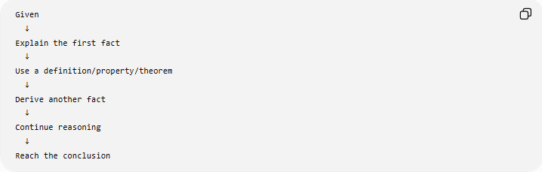
Given
↓
Explain the first fact
↓
Use a definition/property/theorem
↓
Derive another fact
↓
Continue reasoning
↓
Reach the conclusion

Example
# Source: AI Source: Provided by: [Data Path: Persons Table -> ID Column: 1, Name_En Column: Motasem Essam] -> From: [ChatGPT] on [7/25/2026]
Given
$$AB=AC$$
in $△ABC$.
Prove
$$∠B=∠C$$
Paragraph Proof
Since $AB=AC$, triangle $ABC$is an isosceles triangle by the definition of an isosceles triangle. In an isosceles triangle, the angles opposite the equal sides are congruent by the Isosceles Triangle Theorem. Therefore, $∠B=∠C$.
$$\boxed{∠B=∠C}$$

Detailed Example
# Source: AI Source: Provided by: [Data Path: Persons Table -> ID Column: 1, Name_En Column: Motasem Essam] -> From: [ChatGPT] on [7/25/2026]
Suppose $AB=AC$and $AD$bisects $∠A$. To prove $BD=DC$, first note that $AB=AC$is given. Since $AD$bisects $∠A$, $∠BAD=∠DAC$. Also, $AD=AD$by the Reflexive Property. Therefore, $△ABD≅△ACD$by SAS. Corresponding parts of congruent triangles are congruent, so $BD=DC$.

Advantages
# Source: AI Source: Provided by: [Data Path: Persons Table -> ID Column: 1, Name_En Column: Motasem Essam] -> From: [ChatGPT] on [7/25/2026]
- Natural and readable.
- Good for explaining the reasoning in words.
- More concise than a long two-column proof.
- Useful when several mathematical ideas are connected in a continuous argument.

Limitation
# Source: AI Source: Provided by: [Data Path: Persons Table -> ID Column: 1, Name_En Column: Motasem Essam] -> From: [ChatGPT] on [7/25/2026]
The individual statements and reasons are less visually separated, so missing or weak justifications can be harder to notice.

3. Flow Proof

Definition
# Source: AI Source: Provided by: [Data Path: Persons Table -> ID Column: 1, Name_En Column: Motasem Essam] -> From: [ChatGPT] on [7/25/2026]
A Flow Proof represents a proof using a diagram of boxes, arrows, and logical relationships.
Each box contains a statement or fact, and arrows show how one fact leads to another.

Basic Structure
# Source: AI Source: Provided by: [Data Path: Persons Table -> ID Column: 1, Name_En Column: Motasem Essam] -> From: [ChatGPT] on [7/25/2026]
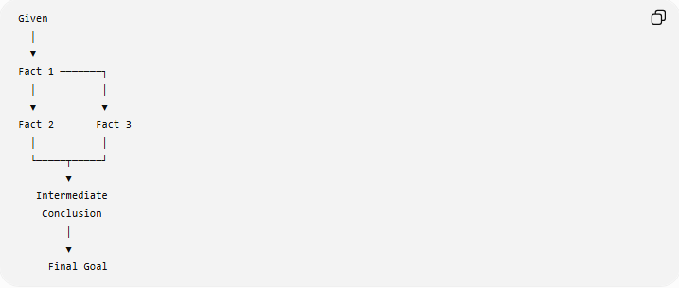
Given
│
▼
Fact 1 ───────┐
│ │
▼ ▼
Fact 2 Fact 3
│ │
└─────┬─────┘
▼
Intermediate
Conclusion
│
▼
Final Goal
Reasons may be written inside or beside the connections.

Example
# Source: AI Source: Provided by: [Data Path: Persons Table -> ID Column: 1, Name_En Column: Motasem Essam] -> From: [ChatGPT] on [7/25/2026]
Given
$$AB=AC$$
in $△ABC$.
Prove
$$∠B=∠C$$
A simple flow proof is:
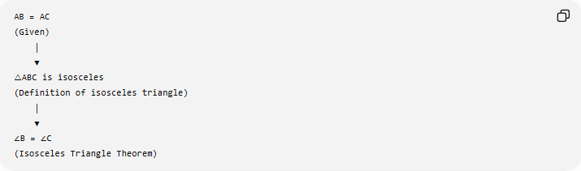
AB = AC
(Given)
│
▼
△ABC is isosceles
(Definition of isosceles triangle)
│
▼
∠B = ∠C
(Isosceles Triangle Theorem)

Example Using Congruent Triangles
# Source: AI Source: Provided by: [Data Path: Persons Table -> ID Column: 1, Name_En Column: Motasem Essam] -> From: [ChatGPT] on [7/25/2026]
Given:
$$AB=AC$$
and $AD$bisects $∠A$.
Goal:
$$BD=DC$$
Flow:
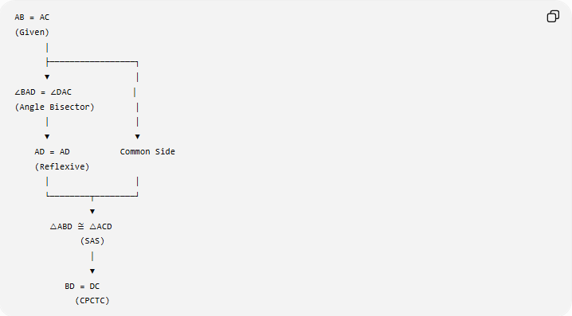
AB = AC
(Given)
│
├─────────────────┐
▼ │
∠BAD = ∠DAC │
(Angle Bisector) │
│ │
▼ ▼
AD = AD Common Side
(Reflexive)
│ │
└────────┬────────┘
▼
△ABD ≅ △ACD
(SAS)
│
▼
BD = DC
(CPCTC)

Advantages
# Source: AI Source: Provided by: [Data Path: Persons Table -> ID Column: 1, Name_En Column: Motasem Essam] -> From: [ChatGPT] on [7/25/2026]
- Shows logical relationships visually.
- Makes branching reasoning easy to see.
- Useful for complicated proofs.
- Helps show that several facts combine to produce a conclusion.

Limitation
# Source: AI Source: Provided by: [Data Path: Persons Table -> ID Column: 1, Name_En Column: Motasem Essam] -> From: [ChatGPT] on [7/25/2026]
Large proofs can become visually complicated.

Comparison of the Three Formats
# Source: AI Source: Provided by: [Data Path: Persons Table -> ID Column: 1, Name_En Column: Motasem Essam] -> From: [ChatGPT] on [7/25/2026]
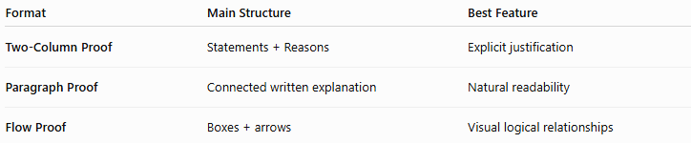
Format | Main Structure | Best Feature
Two-Column Proof | Statements + Reasons | Explicit justification
Paragraph Proof | Connected written explanation | Natural readability
Flow Proof | Boxes + arrows | Visual logical relationships

Same Proof in Three Formats
Consider:
Given
$$AB=AC$$
Prove
$$∠B=∠C$$

Two-Column
# Source: AI Source: Provided by: [Data Path: Persons Table -> ID Column: 1, Name_En Column: Motasem Essam] -> From: [ChatGPT] on [7/25/2026]
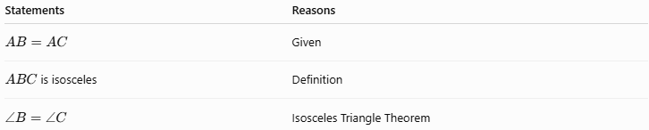
Statements | Reasons
$$AB=AC$$ | Given
$ABC$is isosceles | Definition
$$∠B=∠C$$ | Isosceles Triangle Theorem

Paragraph
# Source: AI Source: Provided by: [Data Path: Persons Table -> ID Column: 1, Name_En Column: Motasem Essam] -> From: [ChatGPT] on [7/25/2026]
Since $AB=AC$, $△ABC$is isosceles. Therefore, its base angles are congruent by the Isosceles Triangle Theorem, so $∠B=∠C$.

Flow
# Source: AI Source: Provided by: [Data Path: Persons Table -> ID Column: 1, Name_En Column: Motasem Essam] -> From: [ChatGPT] on [7/25/2026]
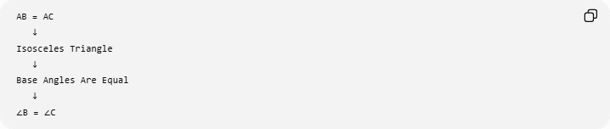
AB = AC
↓
Isosceles Triangle
↓
Base Angles Are Equal
↓
∠B = ∠C
The mathematical proof is essentially the same; only the presentation changes.

Presentation Format vs Logical Proof Method
# Source: AI Source: Provided by: [Data Path: Persons Table -> ID Column: 1, Name_En Column: Motasem Essam] -> From: [ChatGPT] on [7/25/2026]
This distinction is very important.
Presentation Formats
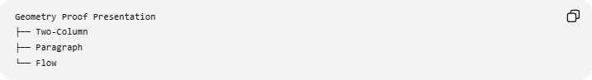
Geometry Proof Presentation
├── Two-Column
├── Paragraph
└── Flow
These answer:
How should I write or display the proof?

Logical Proof Methods
# Source: AI Source: Provided by: [Data Path: Persons Table -> ID Column: 1, Name_En Column: Motasem Essam] -> From: [ChatGPT] on [7/25/2026]
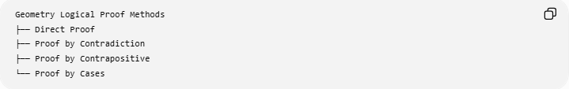
Geometry Logical Proof Methods
├── Direct Proof
├── Proof by Contradiction
├── Proof by Contrapositive
└── Proof by Cases
These answer:
How is the conclusion logically established?

Geometric Proof Frameworks
# Source: AI Source: Provided by: [Data Path: Persons Table -> ID Column: 1, Name_En Column: Motasem Essam] -> From: [ChatGPT] on [7/25/2026]
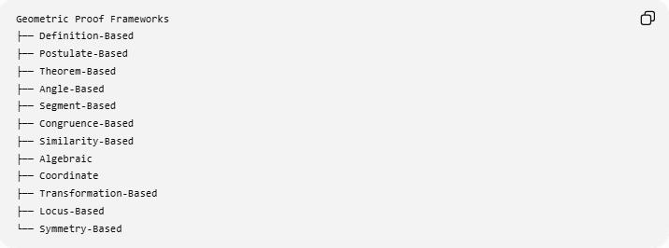
Geometric Proof Frameworks
├── Definition-Based
├── Postulate-Based
├── Theorem-Based
├── Angle-Based
├── Segment-Based
├── Congruence-Based
├── Similarity-Based
├── Algebraic
├── Coordinate
├── Transformation-Based
├── Locus-Based
└── Symmetry-Based
These answer:
What mathematical/geometric tools are primarily used?

The Three Layers of a Geometry Proof
# Source: AI Source: Provided by: [Data Path: Persons Table -> ID Column: 1, Name_En Column: Motasem Essam] -> From: [ChatGPT] on [7/25/2026]
A single proof can belong to all three categories simultaneously:
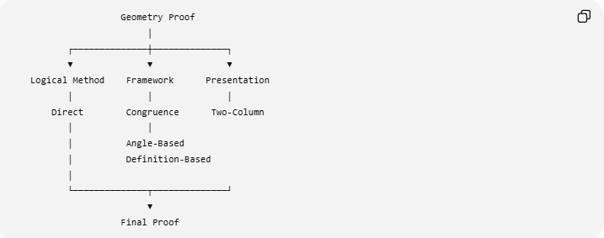
Geometry Proof
│
┌──────────────┼──────────────┐
▼ ▼ ▼
Logical Method Framework Presentation
│ │ │
Direct Congruence Two-Column
│ │
│ Angle-Based
│ Definition-Based
│
└──────────────┬──────────────┘
▼
Final Proof
For example:
A proof can be a Direct Proof, using a Congruence-Based Framework, presented as a Two-Column Proof.
Therefore:
$$\boxed{\text{Logical Method}≠\text{Geometric Framework}≠\text{Presentation Format}}$$

Choosing a Presentation Format

Two-Column Proof
# Source: AI Source: Provided by: [Data Path: Persons Table -> ID Column: 1, Name_En Column: Motasem Essam] -> From: [ChatGPT] on [7/25/2026]
Useful when:
- every step needs an explicit justification;
- learning formal proof writing;
- checking whether each step is valid.

Paragraph Proof
# Source: AI Source: Provided by: [Data Path: Persons Table -> ID Column: 1, Name_En Column: Motasem Essam] -> From: [ChatGPT] on [7/25/2026]
Useful when:
- the proof is relatively short;
- the reasoning is naturally sequential;
- readability is more important than tabular structure.

Flow Proof
# Source: AI Source: Provided by: [Data Path: Persons Table -> ID Column: 1, Name_En Column: Motasem Essam] -> From: [ChatGPT] on [7/25/2026]
Useful when:
- the proof has several logical branches;
- multiple facts combine into one conclusion;
- visualizing the reasoning is helpful.

Classification Summary
# Source: AI Source: Provided by: [Data Path: Persons Table -> ID Column: 1, Name_En Column: Motasem Essam] -> From: [ChatGPT] on [7/25/2026]
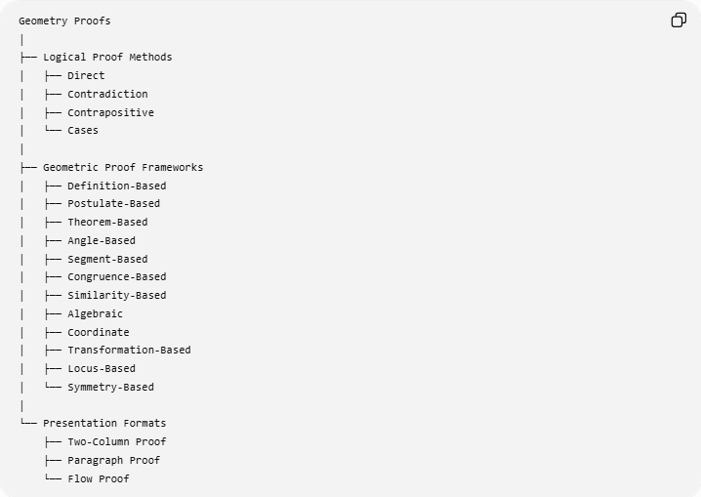
Geometry Proofs
│
├── Logical Proof Methods
│ ├── Direct
│ ├── Contradiction
│ ├── Contrapositive
│ └── Cases
│
├── Geometric Proof Frameworks
│ ├── Definition-Based
│ ├── Postulate-Based
│ ├── Theorem-Based
│ ├── Angle-Based
│ ├── Segment-Based
│ ├── Congruence-Based
│ ├── Similarity-Based
│ ├── Algebraic
│ ├── Coordinate
│ ├── Transformation-Based
│ ├── Locus-Based
│ └── Symmetry-Based
│
└── Presentation Formats
├── Two-Column Proof
├── Paragraph Proof
└── Flow Proof

Key Points
# Source: AI Source: Provided by: [Data Path: Persons Table -> ID Column: 1, Name_En Column: Motasem Essam] -> From: [ChatGPT] on [7/25/2026]
- Two-column, paragraph, and flow proofs are presentation formats.
- A presentation format describes how a proof is organized, not how the proof is logically constructed.
- The two-column format separates statements from reasons.
- The paragraph format integrates statements and reasons into continuous prose.
- The flow format uses boxes and arrows to show logical relationships.
- The same geometric proof can be converted from one format to another without changing its mathematical conclusion.
- A proof can simultaneously have a logical method, a geometric framework, and a presentation format.

Conclusion
# Source: AI Source: Provided by: [Data Path: Persons Table -> ID Column: 1, Name_En Column: Motasem Essam] -> From: [ChatGPT] on [7/25/2026]
Geometry Proof Presentation Formats provide different ways to communicate a mathematical proof. The three principal formats are Two-Column Proof, Paragraph Proof, and Flow Proof. They do not represent different kinds of mathematical truth; rather, they provide different structures for showing the same logical reasoning clearly.
$$\boxed{\text{Proof Method}+\text{Geometric Framework}+\text{Presentation Format}=\text{Complete Proof Structure}}$$

